Firewall Security Lab – Windows Defender Firewall
Ernesto Perez

1. Lab Objective
The aim of this lab was to practise basic firewall configuration and testing on a Windows 11 workstation.
I wanted to:
- Capture a baseline of normal network connectivity
- Create a small set of inbound and outbound firewall rules that block risky services
- Test and record how those rules change network behaviour
- Reflect on how host-based firewalls can reduce attack surface in a home or small business environment
All changes were done locally on my own machine for learning purposes only.

2. Lab Environment
- Operating system: Windows 11 (home lab laptop/desktop)
- Firewall: Windows Defender Firewall with Advanced Security
- User account: Local admin (used only while changing firewall settings)
- Network: Home Wi-Fi connection (NAT behind router)
- Tools used:
  - Windows PowerShell (Admin)
  - ping, tracert, Test-NetConnection
  - Windows Defender Firewall GUI

3. Baseline Connectivity Tests (Before Rules)
Before touching the firewall, I ran some quick tests to show how the network behaved with default settings.
Commands used:
ping 8.8.8.8
ping google.com
tracert google.com
- All pings were successful (ICMP replies received).
- tracert google.com completed normally and showed the path through several ISP hops to Google.
I saved the outputs in:
Reports\baseline_network_tests.txt
Screenshot to capture:
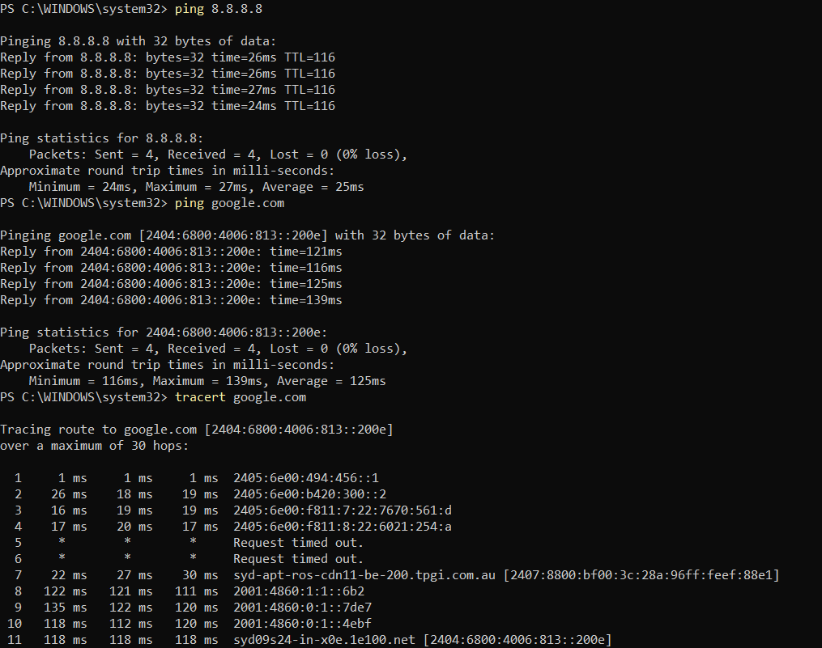

This baseline is useful later when comparing behaviour after firewall rules are applied.

4. Firewall Rules Implemented
I focused on a few realistic outbound rules that block risky services and then allow only essential traffic.
Note: If you changed the exact ports or names, adjust the table to match what you actually created.
4.1 Outbound Block Rules
Rule Name | Direction | Protocol / Port / Address | Action | Purpose / Reason
Block Telnet Outbound | Outbound | TCP port 23 | Block | Telnet sends credentials in clear text; rarely needed.
Block FTP Outbound | Outbound | TCP port 21 | Block | Old file transfer protocol, often unencrypted.
Block SMB Outbound | Outbound | TCP port 445 | Block | Prevents SMB file sharing traffic leaving the host.
Block RDP Outbound | Outbound | TCP port 3389 | Block | Reduces risk of outbound RDP to unknown remote hosts.
Block Malware Range | Outbound | Example IP range (45.155.204.0/24) | Block | Simulated blocking of known malicious IP range.
Example commands (one per rule):
- New-NetFirewallRule -DisplayName "Block Telnet Outbound" -Direction Outbound -Protocol TCP -RemotePort 23 -Action Block
- New-NetFirewallRule -DisplayName "Block FTP Outbound" -Direction Outbound -Protocol TCP -RemotePort 21 -Action Block
- New-NetFirewallRule -DisplayName "Block SMB Outbound" -Direction Outbound -Protocol TCP -RemotePort 445 -Action Block
- New-NetFirewallRule -DisplayName "Block RDP Outbound" -Direction Outbound -Protocol TCP -RemotePort 3389 -Action Block
- New-NetFirewallRule -DisplayName "Block Malware Range" -Direction Outbound -RemoteAddress 45.155.204.0/24 -Action Block

4.2 Outbound Allow Rules (Essential Services)
Rule Name | Direction | Protocol / Port / Address | Action | Purpose / Reason
Allow DNS Outbound | Outbound | UDP port 53 | Allow | DNS queries so the system can resolve domains.
Allow HTTPS Outbound | Outbound | TCP port 443 | Allow | Secure web browsing and most modern applications.
Allow Windows Update | Outbound | Example MS range (13.107.0.0/16) | Allow | Let Windows contact update servers.
Example commands:
- New-NetFirewallRule -DisplayName "Allow DNS Outbound" -Direction Outbound -Protocol UDP -RemotePort 53 -Action Allow
- New-NetFirewallRule -DisplayName "Allow HTTPS Outbound" -Direction Outbound -Protocol TCP -RemotePort 443 -Action Allow
- New-NetFirewallRule -DisplayName "Allow Windows Update" -Direction Outbound -RemoteAddress 13.107.0.0/16 -Action Allow
Screenshot to capture:
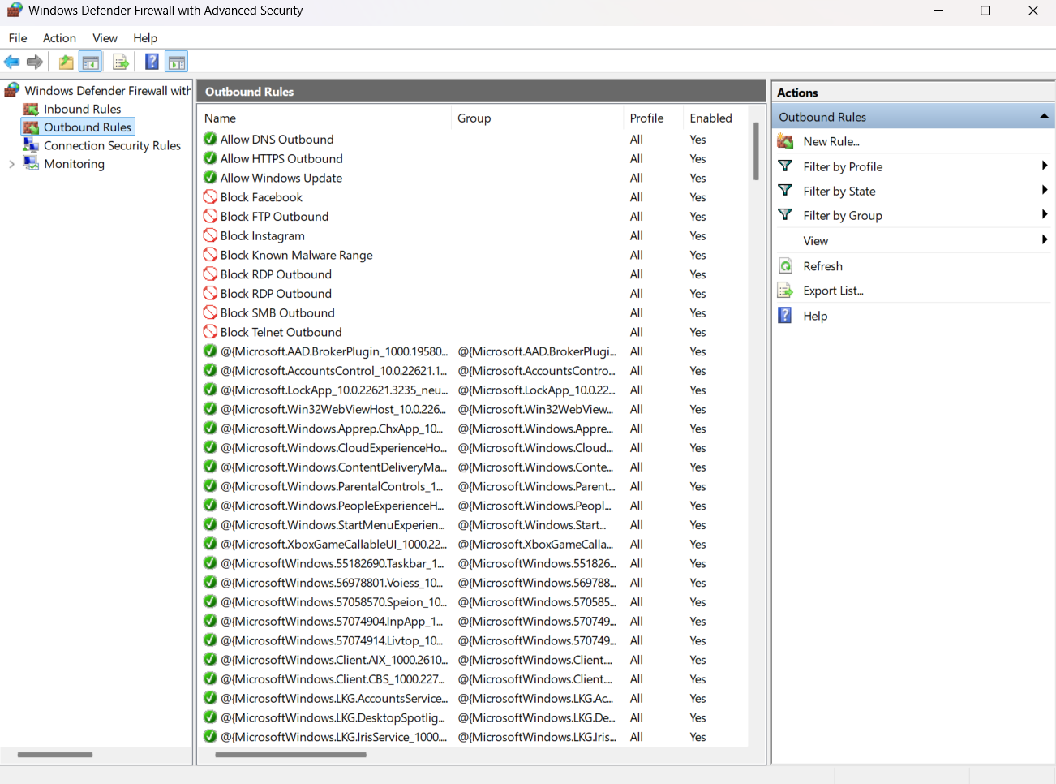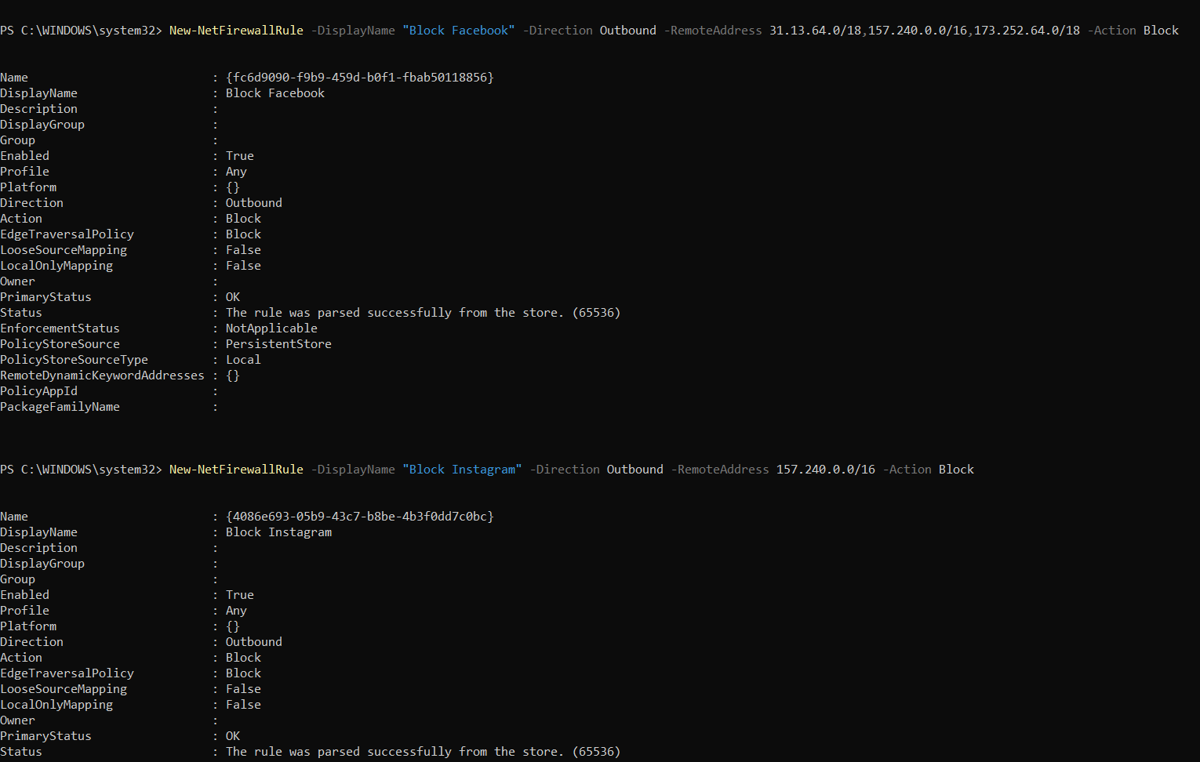

5. Testing the Rules
After creating the rules, I ran tests to confirm they actually changed network behaviour.
5.1 Test 1 – Telnet (port 23) Block
Command:
Test-NetConnection -ComputerName google.com -Port 23
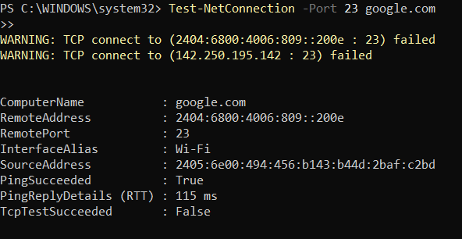
- Expected: Connection fails / blocked by firewall.
- Actual:<Block>
- Result: <Fail>
5.2 Test 2 – FTP (port 21) Block
Test-NetConnection -ComputerName google.com -Port 21
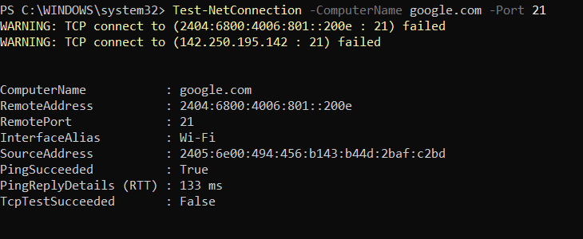
- Expected: blocked
- Actual: <Block>
- Result: <Fail>
5.3 Test 3 – SMB (port 445) Block
Test-NetConnection -ComputerName google.com -Port 445
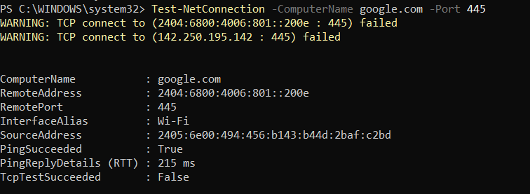
- Expected: blocked
- Actual: <Block>
- Result: <Fail>
5.4 Test 4 – HTTPS (port 443) Still Allowed
Test-NetConnection -ComputerName google.com -Port 443
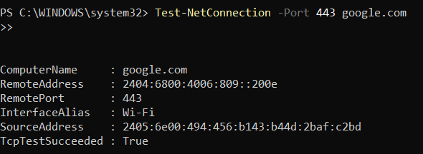
- Expected: Success (firewall allows outbound HTTPS)
- Actual: <Success>
- Result: <Pass>
I also tested by opening a normal website in the browser. If pages still load, it shows that HTTPS is working while the blocked ports stay restricted.

6. Managing / Reverting Rules
For safety, I noted how to disable or remove the rules after the lab:
Disable one rule without deleting it
Disable-NetFirewallRule -DisplayName "Block Telnet Outbound"

Re-enable it later
Enable-NetFirewallRule -DisplayName "Block Telnet Outbound"

Completely remove a rule
Remove-NetFirewallRule -DisplayName "Block Telnet Outbound"
This is useful if a rule accidentally breaks something important.

7. Summary and Analysis
This small lab showed how a host-based firewall can be used to harden a Windows machine without needing any extra hardware.
Key points I observed:
- Even a few targeted outbound rules (Telnet, FTP, SMB, RDP) already reduce a lot of attack surface, especially for older or legacy protocols that send data unencrypted.
- It’s easy to accidentally over-block traffic, so testing with Test-NetConnection, ping, and a browser is important after each rule.
- Domain-based blocking (e.g. facebook.com) doesn’t work directly with Windows firewall rules; it only accepts IP ranges and subnets. That forced me to think more about how IP addressing, DNS, and firewall logic actually fit together.
- Having separate “Allow” rules for DNS and HTTPS made it clear which traffic is intentionally permitted, instead of relying completely on the default profile.
From a defender’s point of view, this kind of host firewall configuration would be a first layer of defence on endpoints, especially laptops that move between different networks. In a real organisation, similar rules could be pushed out via Group Policy or endpoint management tools, and combined with central logging so SOC analysts can see when blocked connections happen.
Overall, the lab helped me practise:
- Using New-NetFirewallRule, Disable-NetFirewallRule, Enable-NetFirewallRule, and Remove-NetFirewallRule
- Reading and testing firewall behaviour from the command line
- Documenting changes with before/after tests and screenshots

